Continuation to eVISION with workflow POC – JCAPS Part 1

Creation of a Connectivity Map
- Right click on ‘prjVISIONBP’ project and select ‘NEW’ connectivity map and rename it to your choice.
- Now drag the Business Process created above from the ‘Enterprise Explorer Window’ onto the canvas of the connectivity map.
- Now drag a ‘Web Connector’ component from the tool bar available on top of the connectivity map onto the canvas.
- Now connect the input (implemented services) and output (invoked services) of the PageFlow service to the ‘Web Connector’ created.
- Now add the below configuration parameters for the inbound eWay (eaWebConnector|eaWebConnector_CMap1_BusinessProcess11) and save it. ( Servlet Context Name – Any name of Your Choice , Authentication Method – FORM , Form Login Page – Login page you created )
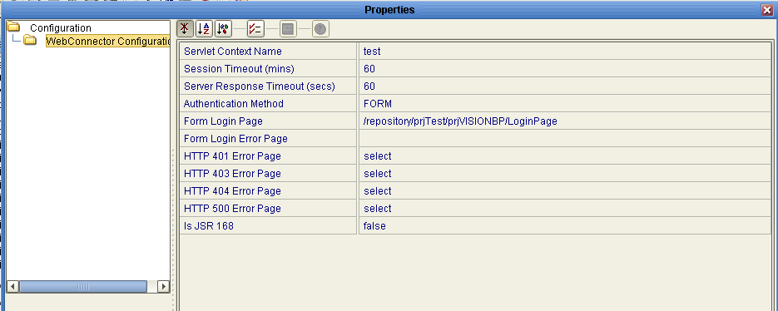

- Now drag 2 ‘External Files’ from the tool bar and link one file to the Input and the other file to the output.
- The Inbound File configuration looks like the following.
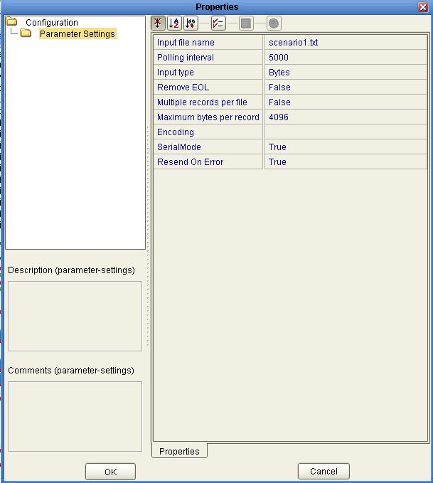
- The outbound File configuration will be like the following.
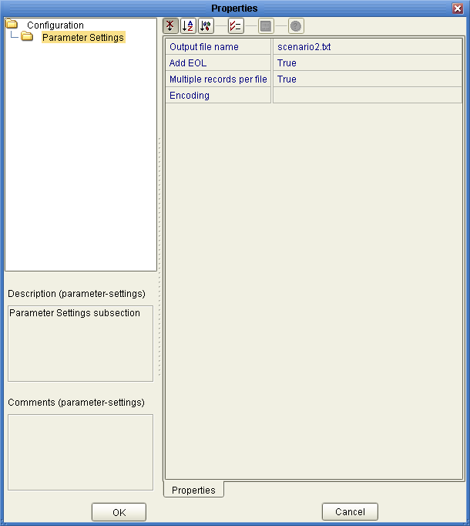
- The connectivity map looks like the following.
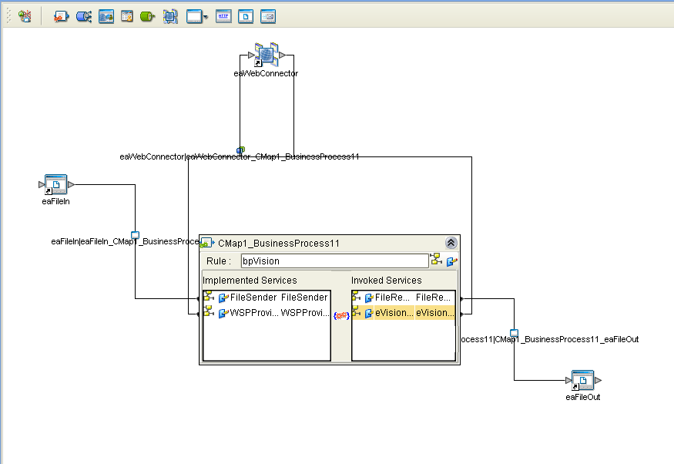

Adding a New eVISION external system in the environment
- Right click on your environment (Assumption – You have already created an environment in the Environment Explorer), select ‘NEW’ and select ‘eVISION External System’ and rename it to your choice.
- Right click the eVISION external system created now and click the properties option. Specify any name of your choice in the ‘User Role’ parameter of ‘Web Connector External System Configuration’ and save it.
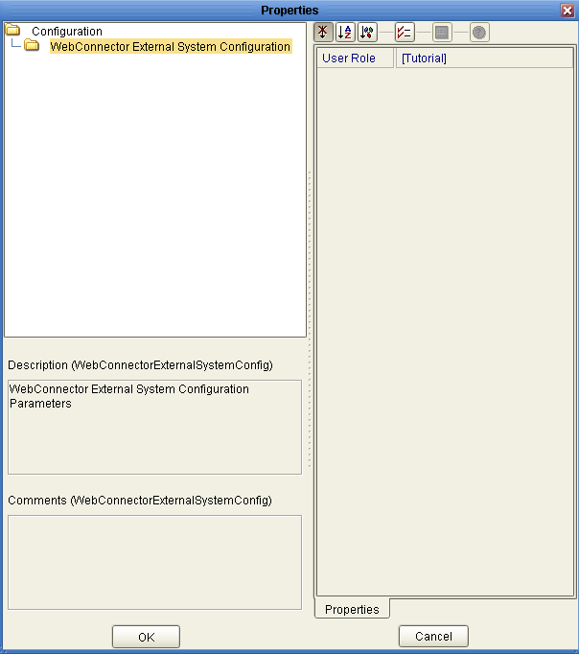

Managing login user in the integration server of the logical host
- Now login to Enterprise Manager(Assumption – Your logicalhost is running) and right click your logicalhost. Now click ‘Manage Integration Server Users’ from the menu.

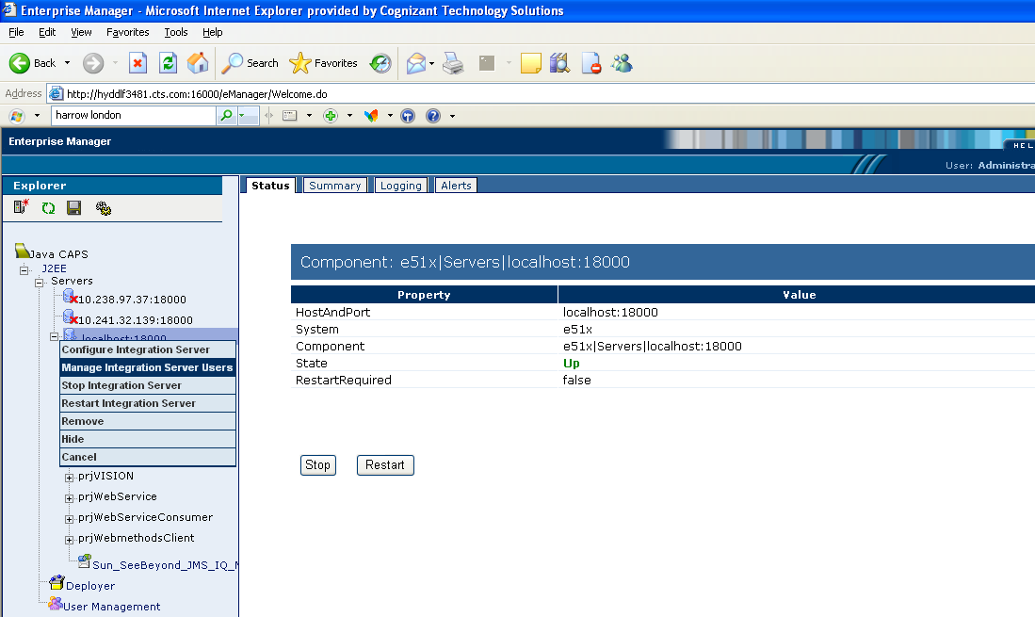

- The User Management portion of the Integration Server Administration tool appears. If the page is not displayed, then check for your proxy settings and disable them.
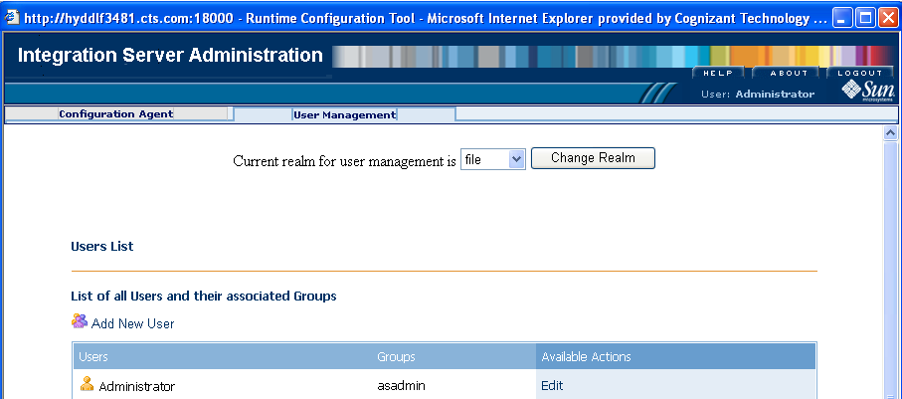

- Add a user by performing the following steps:
  - Click Add New User.
  - Enter information for the new user. In the Group List field, type Tutorial (Parameter you specified in the User Role field of eVISION external system in your environment – Refer Page 20 in this document).
  - Enter Password and click Submit and logout of the Integration Server Administration Tool.
- The final users list would be like the following.
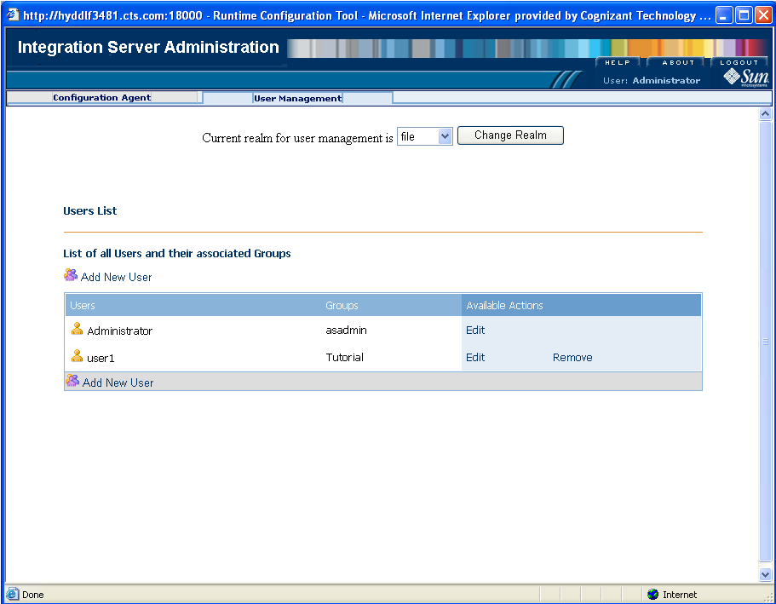
- Now restart your logicalhost again.

Creation of Deployment Profile
- Create a NEW deployment profile for your environment and click the ‘Automap’ option and save it.
- Now click the ‘Build’ button. Once the build was successful, then click the deploy button.

Executing the Web Page
- Start a Web browser and type in the following URL.
http:// [host on which the logicalhost is running -> ex: localhost]: [18001 –http port] / [Servlet Context Name specified in the connectivity map –refer page 16 in this document]
The URL will look like http://10.241.32.141:18001/test

Output Screen Shots
- If the File content is ‘Auto’ , then the case 1 flow is executed and the output file contains a hard coded value ( Value defined in the business rule )
- If the File content is other than ‘Auto’ , following is the flow of web pages
- Login Form
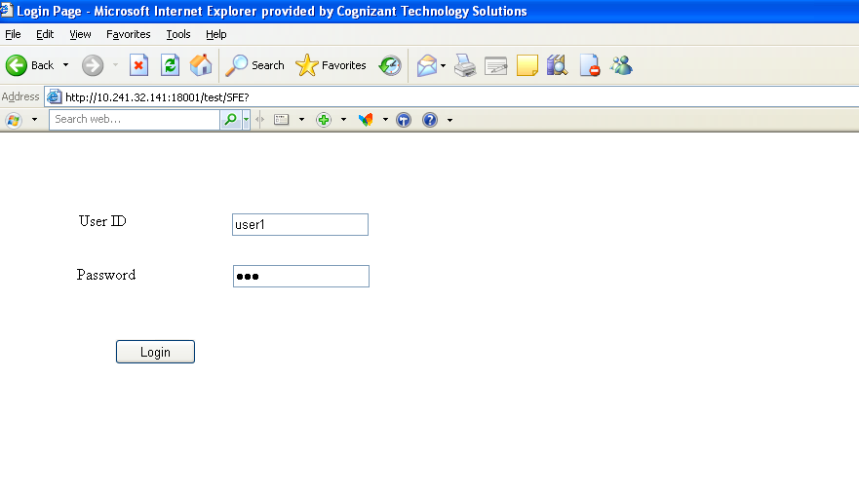

- Bonus Page
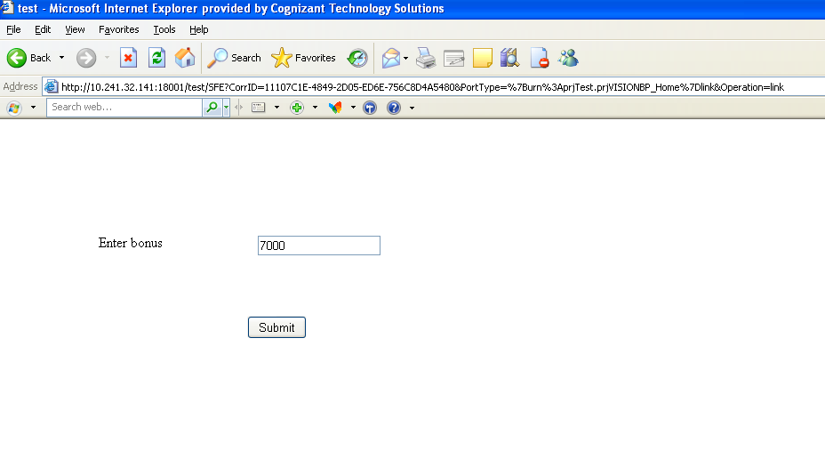
- Output Page

